Visualization Activities with Datasets

Activity 1: Heatmap – Student Performance Analysis
Student | Mathematics | Physics | Chemistry | Programming | English
S1 | 92 | 88 | 84 | 95 | 81
S2 | 76 | 72 | 69 | 80 | 74
S3 | 81 | 78 | 83 | 85 | 79
S4 | 65 | 70 | 68 | 72 | 75
S5 | 90 | 94 | 91 | 96 | 89
S6 | 58 | 62 | 60 | 65 | 70
S7 | 84 | 86 | 82 | 88 | 80
S8 | 71 | 75 | 73 | 77 | 72
S9 | 95 | 91 | 93 | 98 | 94
S10 | 79 | 81 | 77 | 83 | 78

ANSWER:
import pandas as pd
import matplotlib.pyplot as plt
import seaborn as sns

# Student Performance Data
data = {
"Mathematics": [92, 76, 81, 65, 90, 58, 84, 71, 95, 79],
"Physics": [88, 72, 78, 70, 94, 62, 86, 75, 91, 81],
"Chemistry": [84, 69, 83, 68, 91, 60, 82, 73, 93, 77],
"Programming": [95, 80, 85, 72, 96, 65, 88, 77, 98, 83],
"English": [81, 74, 79, 75, 89, 70, 80, 72, 94, 78]
}

students = ["S1","S2","S3","S4","S5","S6","S7","S8","S9","S10"]

df = pd.DataFrame(data, index=students)

plt.figure(figsize=(8,6))
sns.heatmap(df, annot=True, cmap="YlOrRd", linewidths=0.5)
plt.title("Student Performance Heatmap")
plt.xlabel("Subjects")
plt.ylabel("Students")
plt.show()
OUTPUT:
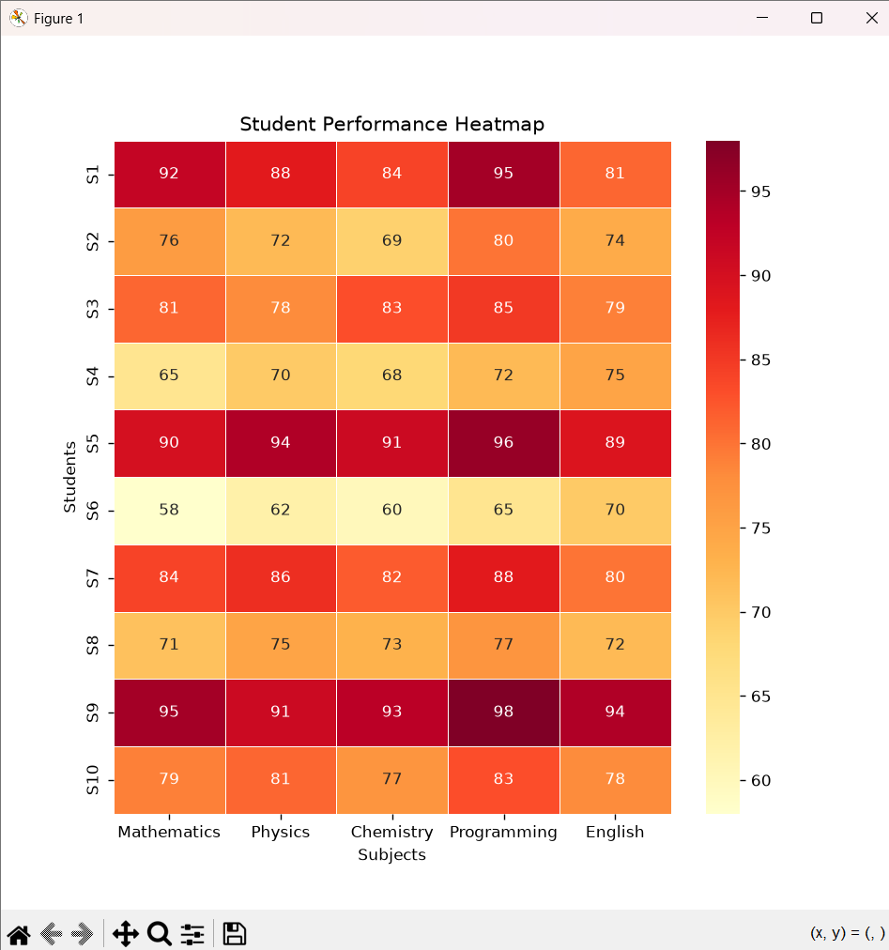
Questions:
- Construct a Heatmap.
ANS: A heatmap is used to display students' marks using different colors. Darker colors represent higher marks, while lighter colors represent lower marks. It helps compare student performance across all subjects quickly.
- Identify highest overall performer.
Ans: Student S9 is the highest overall performer. S9 scored the highest marks in almost every subject with a total of 471 marks. Therefore, S9 has the best overall performance
- Find highest average subject.
Ans: Programming has the highest average marks among all subjects. Most students scored high in Programming compared to other subjects. Hence, Programming is the highest average subject
- Identify students needing support.
Ans: Students S4 and S6 need additional academic support. Their marks are comparatively lower in most subjects. Extra practice and guidance can help improve their performance.
- Explain Heatmap advantages.
Ans: A heatmap makes data easy to understand using colors. It quickly identifies high and low-performing students and subjects. It is useful for comparing large datasets visually.

Activity 2: Violin Plot & Boxplot – Employee Salary Analysis
Employee | HR | IT | Finance | Marketing
E1 | 4.2 | 6.5 | 5.8 | 5.1
E2 | 4.5 | 7.0 | 6.2 | 5.3
E3 | 4.7 | 7.4 | 6.0 | 5.5
E4 | 4.1 | 6.8 | 5.9 | 5.4
E5 | 4.6 | 8.2 | 6.7 | 5.8
E6 | 4.3 | 7.6 | 6.4 | 5.6
E7 | 4.8 | 8.5 | 6.9 | 5.9
E8 | 4.4 | 7.1 | 6.1 | 5.2
E9 | 4.9 | 8.8 | 7.2 | 6.0
E10 | 4.5 | 7.3 | 6.3 | 5.4

CODE:
import pandas as pd
import matplotlib.pyplot as plt
import seaborn as sns

# Employee Salary Dataset
data = {
'HR': [4.2, 4.5, 4.7, 4.1, 4.6, 4.3, 4.8, 4.4, 4.9, 4.5],
'IT': [6.5, 7.0, 7.4, 6.8, 8.2, 7.6, 8.5, 7.1, 8.8, 7.3],
'Finance': [5.8, 6.2, 6.0, 5.9, 6.7, 6.4, 6.9, 6.1, 7.2, 6.3],
'Marketing': [5.1, 5.3, 5.5, 5.4, 5.8, 5.6, 5.9, 5.2, 6.0, 5.4]
}

# Create DataFrame
df = pd.DataFrame(data)

# Convert to long format
salary = df.melt(var_name="Department", value_name="Salary")
# Violin Plot
plt.figure(figsize=(8,6))
sns.violinplot(x="Department", y="Salary", data=salary)
plt.title("Employee Salary Distribution - Violin Plot")
plt.xlabel("Department")
plt.ylabel("Salary (Lakhs)")
plt.show()
# Boxplot
plt.figure(figsize=(8,6))
sns.boxplot(x="Department", y="Salary", data=salary)
plt.title("Employee Salary Distribution - Boxplot")
plt.xlabel("Department")
plt.ylabel("Salary (Lakhs)")
plt.show()

OUTPUT:
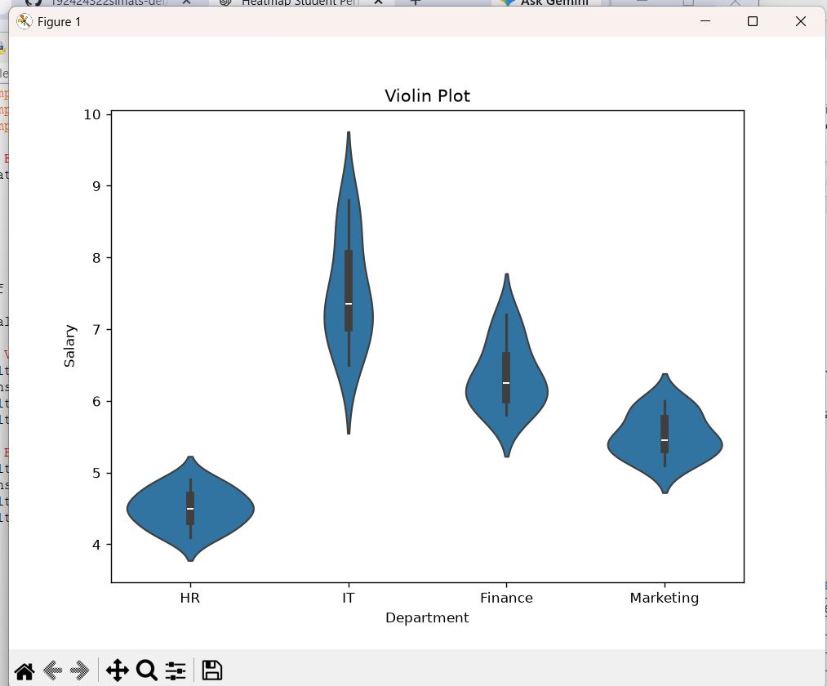

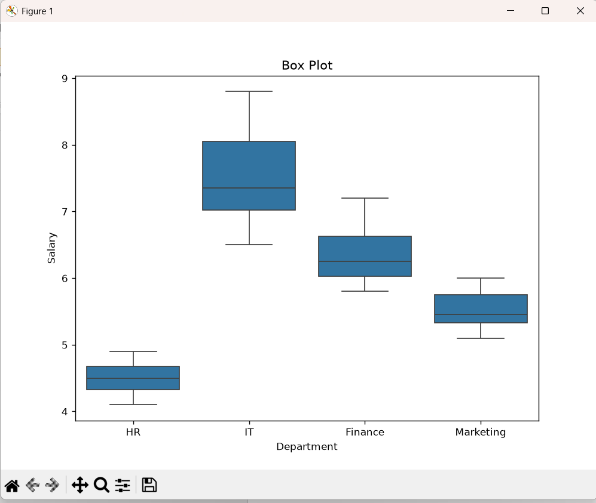Questions:
- Draw violin plots.
ANS: A violin plot is used to display the distribution of employee salaries in each department. It combines a boxplot with a density plot to show how the salary values are spread. This visualization helps compare the salary patterns of different departments.
- Construct boxplots.
ANS: A boxplot summarizes the salary data using the minimum, maximum, median, and quartiles. It helps identify the spread of salaries and any possible outliers in each department. Boxplots make it easy to compare salary distributions between departments.
- Largest variation?
ANS: The IT department has the largest variation in salaries among all departments. Its salary values range from 6.5 lakhs to 8.8 lakhs, showing the widest spread. This indicates that IT employees have the greatest difference in salary levels.
- Highest median?
ANS: The IT department has the highest median salary compared to the other departments. Most IT employees receive higher salaries, resulting in a larger middle value. Therefore, IT has the highest median salary distribution.
- Which plot better represents distribution?
ANS: The violin plot better represents the salary distribution because it shows both the spread and the density of the data. Unlike a boxplot, it provides more information about the shape of the distribution. Hence, the violin plot is more suitable for understanding salary patterns.

Activity 3: Histogram & Density Plot – Website Response Time
Obs | Response Time (ms)
1 | 210
2 | 225
3 | 230
4 | 240
5 | 250
6 | 260
7 | 270
8 | 280
9 | 285
10 | 290
11 | 300
12 | 305
13 | 310
14 | 315
15 | 320
16 | 330
17 | 340
18 | 350
19 | 360
20 | 380

CODE:
import matplotlib.pyplot as plt
import seaborn as sns

# Website Response Time Data
response_time = [210,225,230,240,250,260,270,280,285,290,
300,305,310,315,320,330,340,350,360,380]

# Histogram
plt.figure(figsize=(8,5))
plt.hist(response_time, bins=8, color='skyblue', edgecolor='black')
plt.title("Histogram of Website Response Time")
plt.xlabel("Response Time (ms)")
plt.ylabel("Frequency")
plt.show()

# Density Plot
plt.figure(figsize=(8,5))
sns.kdeplot(response_time, fill=True, color='green')
plt.title("Density Plot of Website Response Time")
plt.xlabel("Response Time (ms)")
plt.ylabel("Density")
plt.show()

OUTPUT:
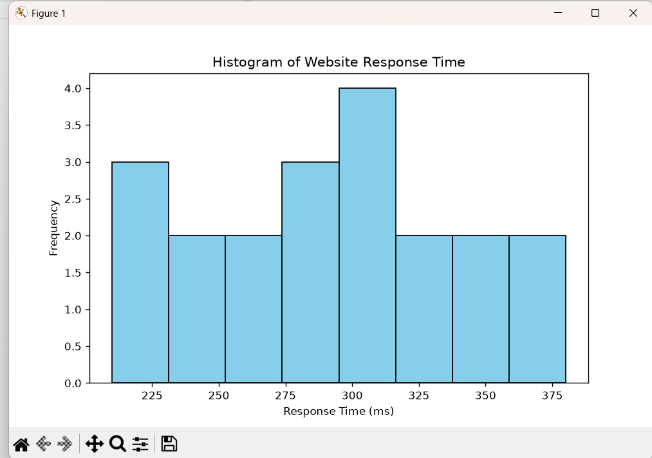

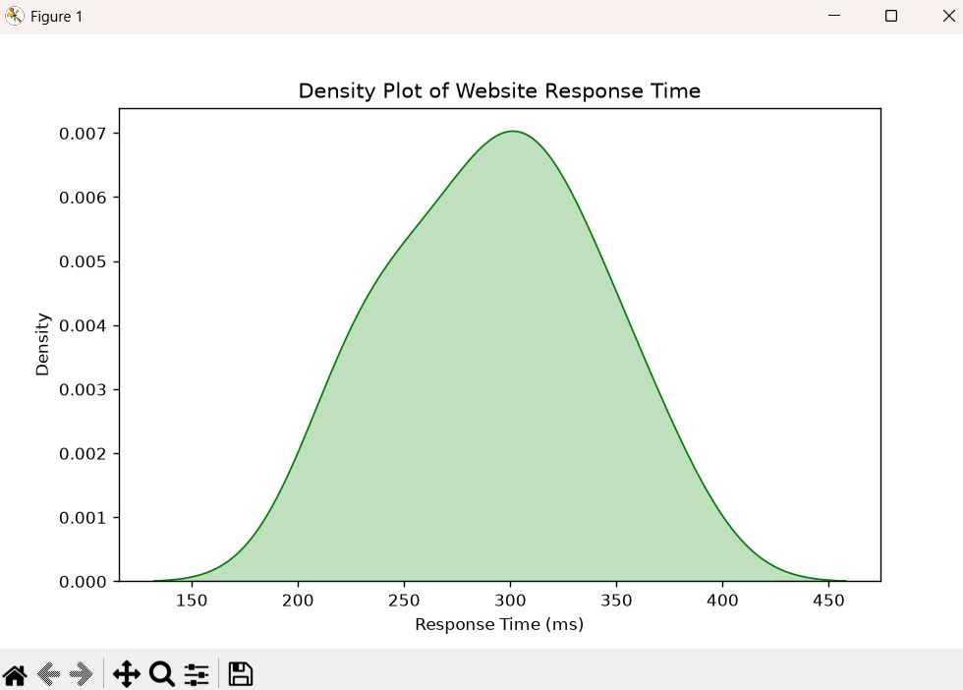

Questions:
- Draw histogram.
ANS: A histogram shows how the website response times are distributed across different intervals. It groups the response times into bins and displays their frequencies. This helps in understanding the overall distribution of the data.
- Plot density.
Ans: A density plot provides a smooth curve representing the distribution of response times. It helps identify where most response times are concentrated. The density plot is useful for understanding the shape of the data.
- Determine skewness.
Ans: The response time data is slightly positively skewed (right-skewed). Most values are concentrated between 250 ms and 330 ms, with a few higher values extending to 380 ms. This creates a longer tail on the right side of the distribution.
- Common range.
Ans: The most common response times fall between 250 ms and 330 ms. Most observations are concentrated within this interval. This indicates that the website usually responds within this range.
- Which plot better represents distribution?
ANS: The density plot better represents the distribution because it provides a smooth view of the data. It clearly shows the overall pattern and concentration of response times. Therefore, it is more effective for understanding the distribution than a histogram.

Activity 4: Ridgeline Plot – Electricity Consumption
House | Jan | Feb | Mar | Apr | May
H1 | 220 | 235 | 250 | 275 | 295
H2 | 240 | 245 | 260 | 285 | 305
H3 | 230 | 238 | 255 | 280 | 300
H4 | 215 | 228 | 248 | 270 | 292
H5 | 225 | 240 | 258 | 282 | 298
H6 | 245 | 250 | 265 | 290 | 310
H7 | 235 | 242 | 259 | 284 | 302
H8 | 228 | 236 | 252 | 278 | 297
H9 | 238 | 246 | 262 | 287 | 307
H10 | 232 | 239 | 256 | 281 | 301

CODE:
import matplotlib.pyplot as plt

# Electricity Consumption Data
jan = [220,240,230,215,225,245,235,228,238,232]
feb = [235,245,238,228,240,250,242,236,246,239]
mar = [250,260,255,248,258,265,259,252,262,256]
apr = [275,285,280,270,282,290,284,278,287,281]
may = [295,305,300,292,298,310,302,297,307,301]

# Plot
plt.figure(figsize=(8,6))

plt.plot(jan, label='January', marker='o')
plt.plot(feb, label='February', marker='o')
plt.plot(mar, label='March', marker='o')
plt.plot(apr, label='April', marker='o')
plt.plot(may, label='May', marker='o')

plt.title("Electricity Consumption by Month")
plt.xlabel("House Number")
plt.ylabel("Electricity Consumption")
plt.legend()
plt.grid(True)

plt.show()
OUTPUT:
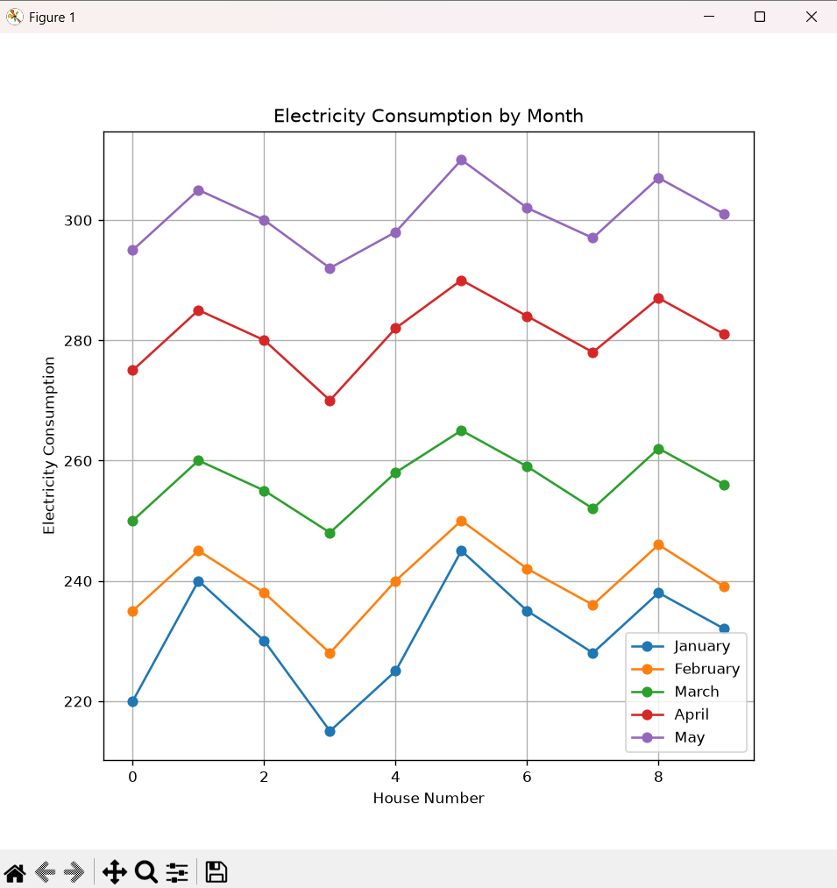

Questions:
- Create ridgeline plot.
ANS: A ridgeline plot displays the distribution of electricity consumption for each month. It helps compare the monthly consumption patterns in a single graph. This visualization clearly shows changes in consumption over time.
- Highest average month?
ANS: May has the highest average electricity consumption among all the months. Most houses recorded their highest usage during May. Therefore, May has the highest average consumption.
- Widest spread?
ANS: The May data has the widest spread of electricity consumption values. The values range from 292 to 310 units, showing greater variation. This indicates that electricity usage differs more across houses in May.
- Describe trend.
ANS: Electricity consumption increases gradually from January to May. Every month shows higher values than the previous month. This indicates a steady upward trend in electricity usage.

- Why ridgeline?
ANS: A ridgeline plot is useful for comparing multiple distributions at the same time. It clearly shows trends, variation, and overlap between different months. It is an effective visualization for time-based distribution data.

Activity 5: Histogram, Density & Boxplot – Daily Steps
Person | 20–30 | 31–45 | 46–60
P1 | 9500 | 8200 | 6500
P2 | 10200 | 8600 | 6700
P3 | 9800 | 8400 | 6900
P4 | 11000 | 9000 | 7200
P5 | 10500 | 8900 | 7000
P6 | 9700 | 8500 | 6800
P7 | 10100 | 8700 | 7100
P8 | 10800 | 9100 | 7300
P9 | 11200 | 9200 | 7400
P10 | 9900 | 8600 | 6950

CODE:
import pandas as pd
import matplotlib.pyplot as plt
import seaborn as sns

# Daily Steps Dataset
data = {
'20-30': [9500,10200,9800,11000,10500,9700,10100,10800,11200,9900],
'31-45': [8200,8600,8400,9000,8900,8500,8700,9100,9200,8600],
'46-60': [6500,6700,6900,7200,7000,6800,7100,7300,7400,6950]
}

df = pd.DataFrame(data)

# Histogram
plt.figure(figsize=(8,5))
plt.hist(df['20-30'], alpha=0.5, label='20-30')
plt.hist(df['31-45'], alpha=0.5, label='31-45')
plt.hist(df['46-60'], alpha=0.5, label='46-60')
plt.title("Histogram of Daily Steps")
plt.xlabel("Daily Steps")
plt.ylabel("Frequency")
plt.legend()
plt.show()

# Density Plot
plt.figure(figsize=(8,5))
sns.kdeplot(df['20-30'], label='20-30', fill=True)
sns.kdeplot(df['31-45'], label='31-45', fill=True)
sns.kdeplot(df['46-60'], label='46-60', fill=True)
plt.title("Density Plot of Daily Steps")
plt.xlabel("Daily Steps")
plt.ylabel("Density")
plt.legend()
plt.show()

# Boxplot
plt.figure(figsize=(8,5))
sns.boxplot(data=df)
plt.title("Boxplot of Daily Steps")
plt.xlabel("Age Group")
plt.ylabel("Daily Steps")
plt.show()

OUTPUT:
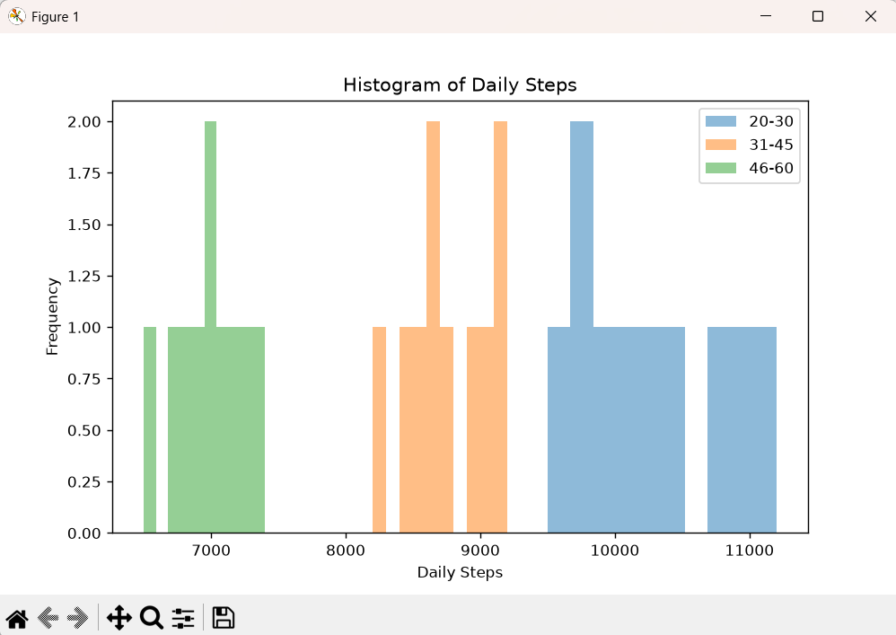

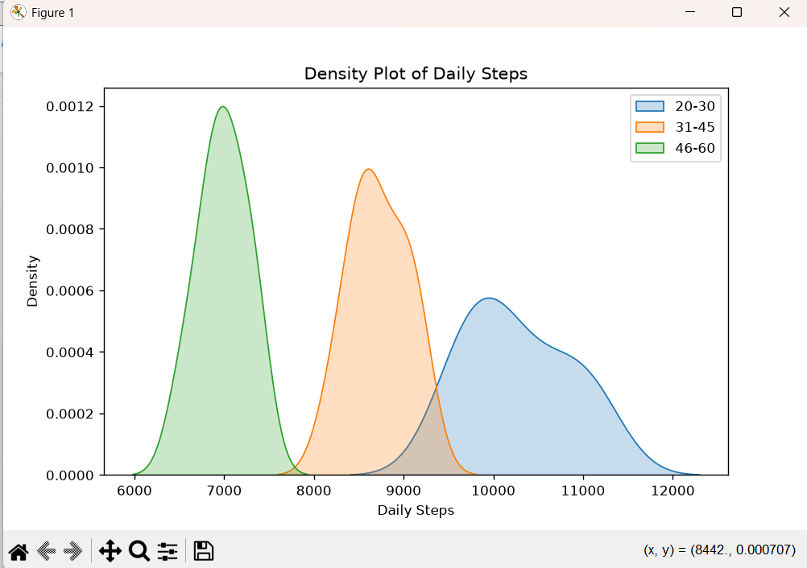

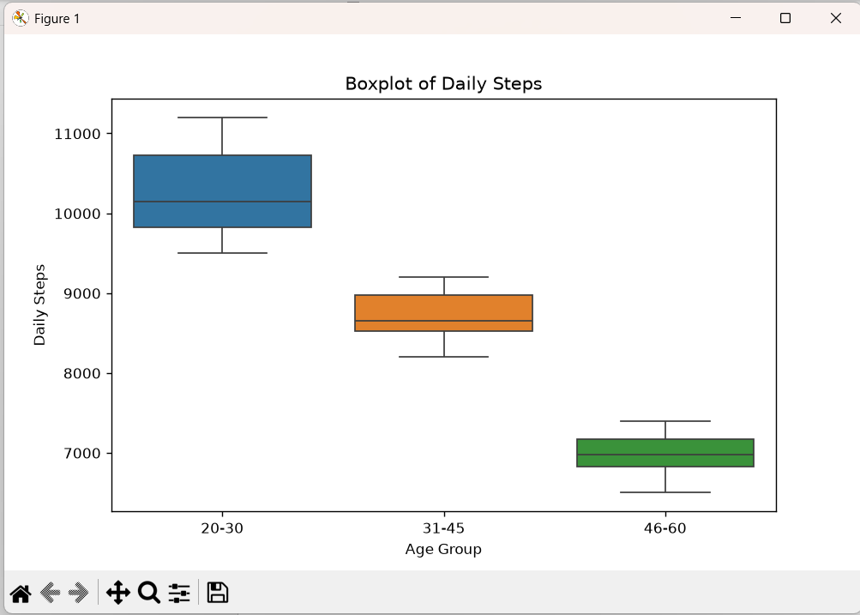

Questions:
- Draw histograms.
ANS: A histogram shows the distribution of daily steps for each age group. It groups the step counts into intervals and displays their frequencies. This helps compare the activity levels of different age groups.
- Plot density curves.
ANS: A density curve provides a smooth representation of the daily step distribution. It shows where most step counts are concentrated for each age group. This makes it easier to compare the overall patterns.
- Create boxplots.
ANS: A boxplot summarizes the daily step data using the median, quartiles, and range. It also helps identify any outliers in the data. This visualization is useful for comparing step distributions among age groups.
- Highest median group?
ANS: The 20–30 age group has the highest median number of daily steps. Most people in this group walk more than those in the other age groups. Therefore, the 20–30 group has the highest median activity level.
- Best visualization and justify.
ANS: The boxplot is the best visualization for comparing daily steps among age groups. It clearly shows the median, spread, and any outliers in the data. Therefore, it provides a simple and effective comparison of the three groups.

